EAI Seminar Series  EUROPARC Atlantic Isles, Section of the EUROPARC Federation embracing the four countries of the United Kingdom, the Republic of Ireland and Iceland | 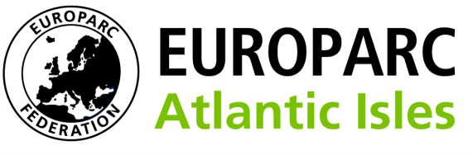  Conservation Without Frontiers

REGISTRATION FORM
The Uses of Apps in Protected Landscapes
VENUE

The Rose Bowl, Leeds Metropolitan University, Civic Quarter, Leeds, LS1 3HE

DATE

Thursday 21st March 2013

COST

Members Rate £120, including lunch and refreshments
Non-Members Rate £180, including lunch and refreshments

To reserve a seminar place please return this form together with proof of payment.

We prefer payment by by BACS to EUROPARC Atlantic Isles / Sort code 60-21-41 / Account 24235342, but we can also accept cheques for the appropriate full amount payable to EUROPARC Atlantic Isles. You can also send us a purchase order number and we can invoice you.

Places are limited so please reserve early to guarantee your participation.

I wish to reserve place(s) at the seminar.

Workshops
Please enter your first and second choice of workshop:

Group 1 (Tourism):

Group 2 (Heritage interpretation):

Group 3 (Biodiversity monitoring):

Rate
Please tick the appropriate rate:

Member Rate. I enclose a cheque or order for the full amount of £120 per person.

Non Member Rate. I enclose a cheque or order for the full amount of £180 per person.

Name(s):

Position(s):

Organisation:

Address:

Post code:

EAI Member*: Yes / No

Telephone:

E-mail:

Diet/Accessibility needs:

*For organisations outside the EAI region please advise if you are a member of the EUROPARC Federation or Eurosite instead.

Please return this form to:

Richard Blackman
Development Adviser, EUROPARC Atlantic Isles

E: richard.blackman@europarc-ai.org
M: +44 (0)7553 125 095

Please e-mail or telephone if you require a postal and/or invoice address.

