

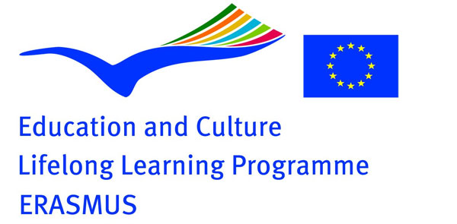

Draft outline for study visit to Dutch National Parks as part of Europarc Atlantic Isles Erasmus+ funded Protected Area Vocational Education and Learning (PAVEL) programm.

We are aiming at a 9 day study visit in June 2018 combining participants.

Programm is a first draft. More content to be developed the next few weeks in more detail and depending on wishes of UK participants

Wednesday 6th June -arrival at Schiphol airport or arrival by Eurostar in Amsterdam
Thursday 7 June:. Transport by self-driver max. 9 person minibus (or normal car depending on final number of participants) to Oosterschelde National Park.
End of afternoon: meet and greet with SNP coordinator Hans Schiphorst and Oosterschelde National Park staff
- General introduction on Dutch National Parks by SNP coordinator. Developments regarding National Parks and the National parks in the Netherlands
- Dinner and informal get together during the evening. Overnight stay in or near Oosterschelde National Park

Friday 8 June: Entire day in Oosterschelde National Park
Meet and greet with NP staff
- Introduction on issues related to visitor-management and related monitoring issues
- Tourism and NP. (How) do entrepeneurs benefit and contribute to the NP
- Governance model for the National Park
- Fieldtrip in Oosterschelde NP
Dinner together with NP staff. Informal get together during the evening. Overnight stay in or near Oosterschelde NP

Saturday 9 June: Morning Travelling to Weerribben-Wieden National Park
Afternoon: meet and greet with NP staff and introduction on:
- Governance model for the National Park
- Introduction of a new NP brand
- Introduction on Junior Ranger programm in Dutch National Parks in general and Weerribben-Wieden National Park in particular
- Fieldtrip in NP
Dinner together with NP staff. Informal get together during the evening. Overnight stay
in or near NP

Sunday 10 June: Day off . If needed, we can discuss options for this day (extended cycling trip?, sailing in traditional boats?)

Monday 11 June: we can discuss options for this day

Tuesday 12 June: Travelling to visitor centre of Dwingelderveld NP
Meet and greet with NP staff
1. Introduction on issues related to visitor-management and related monitoring issues
2. Governance model for the National Park
3. Fieldtrip in Dwingelderveld NP
3. Dinner together with NP staff. Informal get together during the evening. Overnight stay
in or near NP

Wednesday 13 June: Travelling to Drentsche Aa NP
Meet and greet with NP staff
1. Introduction on issues related to visitor-management and related monitoring issues
2. Governance model for the National Park
3. Fieldtrip in Drentsche Aa NP
3. Dinner together with NP staff. Informal get together during the evening. Overnight stay
in or near NP

Thursday 14 June: Travelling to Amsterdam
Visiting Amsterdam under your own steam

Friday 16 June Travelling to Schiphol airport or Amsterdam Station and returning to UK

