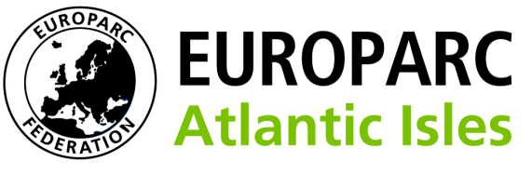
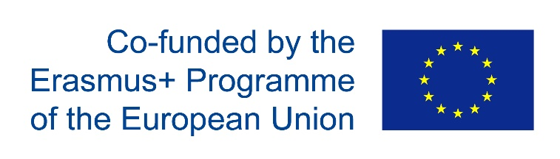
Application for Europarc Atlantic Isles Erasmus+ mobility
Please return this completed application by e-mail to:
anita.prosser@europarc-ai.org

Applicant details
Family name: |  | First name:
Street address:
Postcode: |  | City:
Region: |  | Country;
Telephone: |  | Email:
Date of Birth:
Organisation
Which study visit do you wish to apply to go on?

Proposer/Line Manager
The proposer must be a line Manager. The proposer should complete this part of the application.
Name
Position in Organisation
Telephone(s):
Email:
Nature of relationship with applicant:

Why have you proposed this applicant?

How will this project benefit the applicant learning and development?

How will the applicant's participation benefit your organisation learning?
.

Applicant – About you
The following sections should be completed by the applicant.
Tell us about your role within your organisations

Applicant – Your learning needs
Tell us why you are applying for this placement and what you hope to learn? (Please indicate why you think this specific coutry/proteceted area will hel to address your learning needs
.

Applicant – - Experience to share with partners
What skills and experiences could you share with partners?

Applicant - Sharing your experience
Following your visit to a partner in Europe how will you share your experiences and learning within your protected area or organisation and within the network?

Applicant - Overseas experience
Tell us of any experience you have overseas, but note that this is not a requirement

This information will be stored electronically for the length of the project which is 2 years from 1st July 2016. It will be used only for the purpose of the pre-application, and shared only for this purpose with EAI’s hosting partner organisation.

