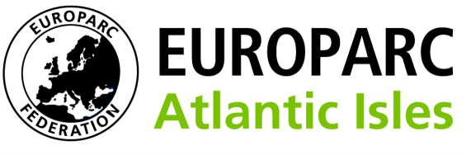
Conservation Without Frontiers

Booking Form

First Name |  | First Name
Job Title

National Park or organisation

Phone |  | Mobile
Email Address

Address

Residential Rate £135 (please mark rate for invoicing) |  | Non-Residential Rate £40
 |  | Attend evening dinner £25
Specific Dietary requirements

Specific Invoice Information

Purchase order Number if required
Are you happy for name to appear on a contact list (please tick if yes)

Please complete the form and return to Anita Prosser – anita.prosser@europarc-ai.org. We will invoice you the appropriate amount and confirm your place

