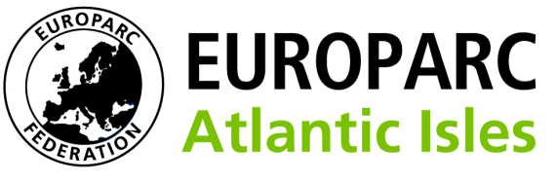

Conservation Without Frontiers

**EUROPARC Atlantic Isles trustee role**

This is a great opportunity for a protected area member of staff or those involved in protected areas, to become involved as a trustee/ Board Member of Europarc Atlantic Isles and a good personal development role.  
   
**What is EUROPARC Atlantic Isles?**   
[EUROPARC Atlantic Isles](https://www.europarc-ai.org/) brings together organisations and individuals, who manage protected areas in England, Northern Ireland, Scotland, Wales, and the Republic of Ireland and is a section of the EUROPARC Federation. Our members bring with them a wealth of experience and expertise from national parks, regional parks, National Landscapes, local authorities, government agencies and non-governmental organisations, including academics and consultants.  
   
We aim to use our strong European and international connections to promote good practice and policy with a core principle of knowledge leadership in protected area management, for the benefit of public good.  
   
**Role of a Board Member**  
The role of a Board Member is to carry out the responsibilities of a trustee of the charity EUROPARC Atlantic Isles (EAI).  As a charity trustee there are certain legal responsibilities to be undertaken:

* Act in your charity’s best interests
* Manage your charity's resources responsibly
* Act with reasonable care and skill

 A Board Member is appointed for a term of three years and can be reappointed for another term. Some board members may have a specific role such as Treasurer.  
   
As a Board Member we would expect trustees to:

* Inform the debate around the activities of EAI
* Develop certain areas of work from time to time
* Represent EAI in their particular area ( geographic/thematic
* inviting applications for the role
* Act as an ambassador on behalf off EAI
* Encourage new paying members in the network
* Attend board meeting 4 times a year – 2 face to face and 2 conference calls

For Board members who are employed staff of our member organisations we ask their organisation to cover travel expenses. EAI is also keen to support contributions from Board members employed outside of member organisations and will discuss how it can cover reasonable out of pocket expenses.  
   
The details of or current Board Members are set out [here](https://www.europarc-ai.org/about-us/).

**The process to recruit new Board Members.**

* EAI will place a general or specific Role  profile on its website, in newsletters and promote to member organisations inviting applications for the role
* Applications to be received by 17thJune 2025 and sent to <mailto:Anita.Prosser@europarc-ai.org>
* Role to commence 1 July 2025
* Applicants will send a CV initially and there maybe follow up meeting
* Applications will be assessed by a subgroup of the board
* EAI may actively go out and target potential board members

**Skills and knowledge required**.

1. Knowledge of Environmental bodies operating across the EAI area.
2. Awareness and understanding of the issues facing these bodies in at least one of the Countries covered by EAI especially land use
3. Negotiation and advocacy
4. Financial management, charity governance, company governance.
5. Good interpersonal skills to deal effectively with a wide range of groups and individuals.
6. Enthusiastic, self-motivated, diplomatic and flexible.
7. Knowledge of the political and strategic context in which Protected areas operate.
8. Interest in wider European environmental issues
9. Funding experience
10. Communications and Social media

We would particularly welcome applications from people representing views from Wales; and also, those from the under-represented and under-supported sectors of our communities, especially young people (either being a young person, or someone actively involved in the youth voice), and/or people from minority ethnic backgrounds.

Please contact  [Anita.Prosser@europarc-ai.org](mailto:Anita.Prosser@europarc-ai.org)  or on 07474949444 after 1st June 2025