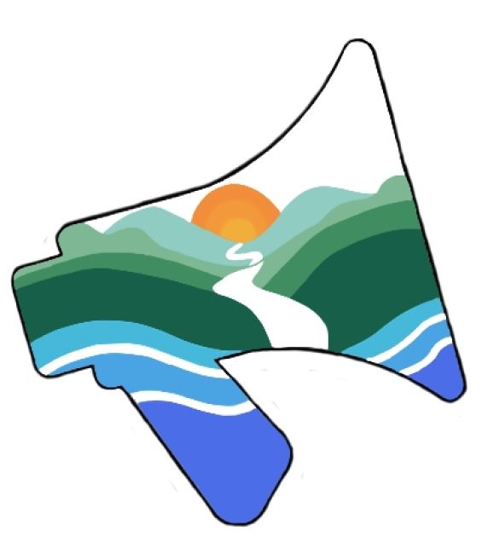

Youth Voice Conference 2026

Impact Report

Contents
Contents 2
Executive summary 3
Overview 4
Delegates 5
Fieldtrips 11
Peatland Restoration, Fylingdale Moor Fire Site 11
Marine Conservation, Boggle Hole 12
Workshops 13
Natural Health Service 13
Dementia Awareness 13
Tom Hind 14
Campaign for National Parks 14
Reconnect Project 16
Activities 17
Delegate presentations 17
Mindfulness Walk 18
Dawn Chorus 18
Stargazing 19
Action planning 20
Key Findings 21
Conclusion 23
Appendix 24

Executive summary
The 2026 Youth Voice Conference brought together 20 young people from nine UK Protected Landscapes, alongside the EUROPARC Youth Council, to strengthen youth participation, collaboration and leadership across the protected landscapes sector. The conference provided an opportunity for delegates to share experiences, learn from one another and develop a collective vision for the future of Youth Voice in the UK.
“The conference achieved its goal for uniting a great group of young people through well planned activities, workshops and downtime.”- Delegate
Through a programme of field visits, workshops, practical activities and collaborative action planning, delegates explored key environmental and social themes including peatland restoration, marine conservation, nature and wellbeing, dementia awareness, inclusive engagement and the future of National Parks. These experiences encouraged participants to exchange ideas, build practical skills and consider how successful initiatives could be adapted within their own Protected Landscapes.
A central outcome of the conference was the recognition that Youth Voice should extend beyond individual organisations to become a connected UK-wide movement. Delegates identified the need for stronger collaboration, improved communication and greater opportunities for young people to influence decision-making, governance and policy across Protected Landscapes. They also highlighted the importance of removing barriers to participation and creating long-term pathways that support leadership development, volunteering and green careers.
The conference demonstrated a strong appetite for continued collaboration. All delegates (100%, 20/20) expressed interest in attending future events and supported the creation of a national Youth Voice network. Participants left with stronger relationships, practical ideas to implement locally and a shared commitment to maintaining communication, developing joint projects and ensuring young people's voices remain central to the future of the UK's Protected Landscapes.
Overall, the conference laid the foundations for a lasting national Youth Voice network, empowering young people to work collectively to shape more inclusive, resilient and sustainable Protected Landscapes for future generations. As young people work with their Protected Landscapes to continue youth voice work, Leaders are working to secure funding to assist young people to continue their collective work on systems change.

Overview
The Youth Voice Conference was established in response to young people's desire to move beyond isolated local opportunities and create a stronger, collective voice across the UK's Protected Landscapes. It provided a space for delegates to build relationships, share good practice and develop a national network capable of influencing future decision-making, while addressing barriers to participation and creating pathways for long-term youth involvement.
The programme combined fieldtrips, workshops and collaborative activities to explore environmental conservation, wellbeing, inclusive engagement and youth leadership. Delegates visited peatland restoration and marine conservation projects, took part in workshops on nature and health, dementia awareness, governance, community engagement and the future of National Parks, and participated in activities including delegate presentations, mindfulness, nature connection and action planning. Together, these experiences encouraged learning, collaboration and the sharing of practical ideas, leaving delegates with stronger connections, greater confidence and a shared commitment to developing Youth Voice across the UK's Protected Landscapes.

Delegates
Delegates represented 8 different Protected Landscapes and a European network of Protected Landscapes;

- North York Moors National Park
- Exmoor National Park
- Yorkshire Dales National Park
- EUROPARC Youth Council
- Lake District National Park
- Ring Of Gullion Area of Outstanding Natural Beauty
- Belfast Hills Partnership
- New Forest National Park
- Peak District National Park

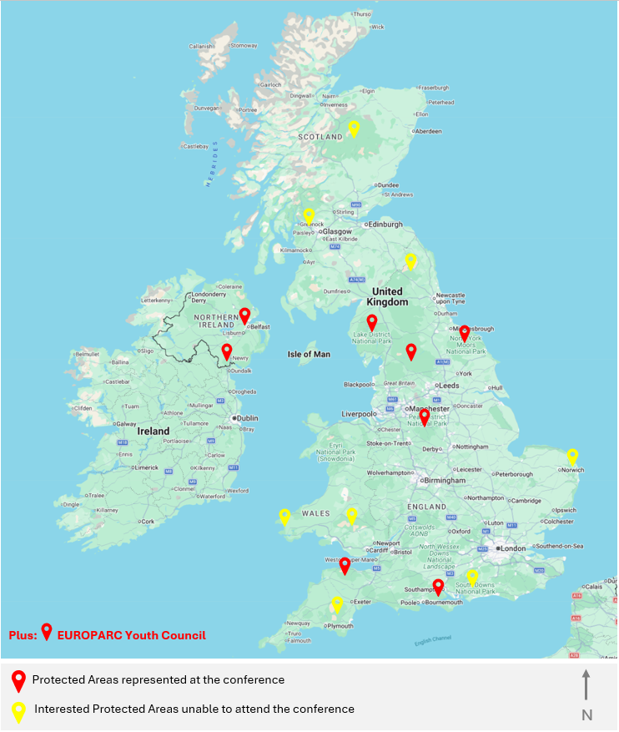

There was also interest from the below Protected Landscapes. Although many do not have any youth voice programme. Others that do were not able to attend at this time.;

- Brecon Beacons National Park (Bannau Brycheiniog National Park)
- Norfolk Broads National Park
- Cairngorms National Park
- Dartmoor National Park
- Northumberland National Park
- South Downs National Park
- Pembrokeshire Coast National Park
- Loch Lomond and The Trossachs National Park

Abigail – Lake District National Park
Abigail has worked in the Development Management team as a planner for the Lake District National Park for 2 years. She is passionate about creating inclusive spaces and is keen to support the voices of underrepresented groups within the landscapes they live, work, and enjoy. Given that the LDNPA are still in the process of setting up their Youth Board, Abigail is excited to learn from others and collaborate across protected landscapes.

Ailish – North York Moors National Park
Ailish has been a member of the North York Moors National Park Explorers, Young Rangers and joined Youth Voice in 2023. She is passionate about inspiring young people to get out and about in nature and feel it’s benefits. She co-organised this conference to help create connections across the youth groups of the UK, and help people come together in a fun, engaging and meaningful way.

Ambar – North York Moors National Park
Ambar has worked for the North York Moors National Park since 2019 and has been part of Youth Voice since 2023. As a ranger, Ambar is passionate about people being able to access and enjoy nature and the countryside. With young people being underrepresented in these areas she is keen to learn more from other people's experiences and build on ideas of what we can do both locally and nationally.

Bonnie – North York Moors National Park
Bonnie joined the Youth Voice group in November 2025 as she has an interest in the natural world, particularly in rewilding and what we can do to help make things wild again. She attended the conference as it was a great way to meet other young people within the sector, sharing ideas and inspiring each other to help give young people a voice.

Charlotte – Peak District National Park
Charlotte has been volunteering for the Peak District National Park for five years, first as an individual and now as a Volunteer Leader helping to support the delivery of practical conservation sessions for young people aged 18 to 30. The Peak District Youth Voice has been ongoing since 2024 and became the Youth Impact Collective in 2025. Charlotte has been involved since the start of the Youth Voice journey and is now a Project Co-Lead for Nature for the group. Attending the conference was an opportunity to learn about how other National Parks and Protected Landscapes give a voice to their young people, and to gain inspiration and connections for the next stages of Youth Voice in the Peak District.

Eva – New Forest National Park
Eva has been a member of the New Forest Youth Board since its launch in September 2024, and since joining has enjoyed connecting with other young people about climate and nature related issues. She was excited to attend the Youth Voice conference to expand the work taking place in the New Forest by connecting with other Youth Voice groups across the country.

Hannah – Lake District National Park
Hannah is PR Assistant for the Lake District National Park Authority and has taken a keen interest in the development of the LDNP Youth Board. The LDNP Youth Board is at a very early stage of development, and Hannah looks forward to helping gather young people to join and give them more of a voice within the National Park.

Hayley – Peak District National Park (EUROPARC Youth Council)
Hayley works as Project Coordinator on the Landscape Connections project at the Peak District National Park Authority, focusing on nature connection through community, volunteering and green career pathways for young people. Before this, she worked for the New Forest National Park Authority where she helped create the New Forest youth Board in 2024. She also became a member of the EUROPARC Youth Council at the end of 2024, and is in term until the end of 2027. She enjoys working with youth in aims to grow and amplify young voices in the green sector, especially within policy and decision making.

Hermione – Yorkshire Dales National Park (EUROPARC Youth Council)
Hermione works as an Outreach Project Officer for the Yorkshire Dales Millennium Trust. Her role involves getting young people and adults from marginalised communities and low-economic backgrounds into the National Park to benefit their mental and physical health. She is currently helping to develop a Youth Ambassador role for the Yorkshire Dales Millennium Trust and was able to get lots of ideas at the conference.

Her personal journey into Youth Voice started in April 2023 when she started as a Community Engagement Trainee at the Yorkshire Dales National Park Authority. She was part of the Youth Forum for staff under 30. She then attended the EUROPARC Conference in 2023 and became a member of the first cohort of the EUROPARC Youth Council. Since then she has done numerous presentations focusing on the barriers for young people living and working in Protected Landscapes and been to conferences across Europe representing the Youth Council. She is happy to use her voice to bring opportunities for young people in Protected Landscapes and believe early careers opportunities are vital for this sector.

Katie – Yorkshire Dales National Park
Katie joined the Yorkshire Dales National Park Authority as a co-opted youth member in December 2024—the first time the Authority had introduced youth members in this way. Since joining, she has enjoyed being part of the finance and resources committee and getting to be involved in other areas of the national parks work. She was excited to get involved in the youth conference, to meet other young people in this sector, creating connections to shape the youth voice in national parks.

Livia – North York Moors National Park
Livia is one of the original members who helped found Youth Voice in the North York Moors National Park. She has volunteered for the NYMNP for nearly 9 years. She Co Organised this Youth Voice Conference as a way for young people in the nature sector across the UK to connect and work together for the future of the nature sector.

Luke – North York Moors National Park
Luke is one of the original members who helped co-found Youth Voice during the Covid-19 pandemic. He has been a volunteer with the NYMNP for nearly 9 years and has a strong passion for wildlife. He attended the conference eager to network with other youth voice groups and to help inspire others.

Millie – Peak District National Park
Millie joined the Peak District Youth Impact Collective from the first residential co-creation weekend and has been attending meetings since. Millie works as a Countryside Ranger so is particularly passionate about nature and getting young people involved in caring about the environment. Millie attended the conference to meet like minded people and to learn from other youth voice groups.

Rose – Exmoor National Park
Rose is one of the founding members of Exmoor Youth Board. The board was only established at the start of 2026, so she was particularly excited to meet other young people and learn about their experiences. The conference was an incredible opportunity to hear from existing groups, to make connections across protected landscapes and to develop ideas in relation to Exmoor.

Ryan – Belfast Hills Area of Outstanding Beauty, Northern Ireland
Ryan is a member of the Landscapes NI youth forum which was founded in November 2025 he is the cooler one of the representatives from the Belfast Hills. Since joining he has had many great opportunities, attending this conference definitely being one of them . Ryan attended the conference hoping to improve his connections and gain a better understanding of the challenges faced by other youth boards/voices and their parks.

Sam – Exmoor National Park
Sam is one of the founding members of the Exmoor National Park youth voice board. The Exmoor youth board is still very new, so this opportunity was a great chance for Sam to meet with and learn from other youth voice groups from across the UK and take back inspiration for Exmoor youth voice.

Tara – Ring of Gullion Area of Outstanding Beauty, Northern Ireland
Tara became a member of the Landscapes NI Youth Forum after completing the volunteer program the AONB and Geopark Youth Leaders. She has always been passionate about nature and protecting the environment. This conference was a chance to meet like-minded people and create a network of young people who are all passionate about conservation. Since the Landscapes NI Youth Forum has only recently been established, this conference was an opportunity to learn from other youth groups and gather ideas on how we can progress.

Tessa – Lake District National Park
Tessa works for the Lake District National Park Authority as Online Officer within the Communications team. She is looking forward to being part of the starting steps for the LDNP Youth Board alongside other team members. The Lake District is a beautiful but complex National Park with its unique challenges and opportunities, with huge potential for growing youth voice.

Toby – New Forest National Park
Toby has been a member of the New Forest Youth Board since its launch in September 2024, Since joining Toby has enjoyed expanding his knowledge and understanding on issues facing the environment, whilst striving to give a platform for youth voice within the New Forest, He was excited to attend the Youth Voice conference to network with other youth groups across the national parks.

Zac – Yorkshire Dales National Park
Zac has been part of the Yorkshire Dales National Park Authority since December 2024, joining with Katie as one of two newly appointed young co-opted members of the Authority. He has loved spending time in the Park, getting to know the Finance and Resource Committee and Full Authority, and helping include young people’s voices in formal governance of the YDNPA. Highlights include creating a Youth Vision Statement, consulting on a national Youth engagement programme, and aiding selection of a new CEO.

Fieldtrips
Fieldtrips were planned on the Saturday as a way for delegates to experience habitats of the North York Moors National Park. Delegates had the opportunity to explore landscapes, special qualities and relevant projects. The exploration led on to learning new skills and learning about the beauty and risks that can befall.

Peatland Restoration, Fylingdale Moor Fire Site
On Saturday morning delegates visited the Fylingdales Moor wildfire site to learn about the devastating impact of the 2025 wildfire and the ongoing peatland restoration work. Edward March-Shawcross, Moor to Restore Project Officer, explained the importance of peatlands for carbon storage, the environmental and community impacts of the 25 km² wildfire, and the challenges of restoring the damaged landscape.

The delegates were joined on site with local farmer Lowell, who shared the effects of the fire on farming and habitat management. Delegates saw restoration work first-hand, including re-wetting peat through drainage blocking and creating firebreaks to reduce future wildfire risk.

The fieldtrip highlighted the shared challenges of wildfire, habitat loss and peatland restoration across the UK's Protected Landscapes. The workshop aimed to encourage delegates to reflect on how these issues affect their own Protected Landscape and how young people can contribute to future restoration projects.

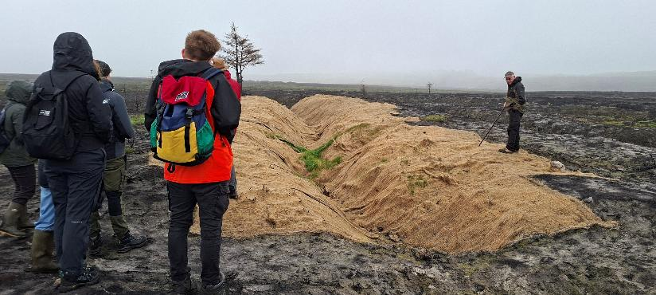

Marine Conservation, Boggle Hole
On Saturday delegates visited Boggle Hole to explore the North York Moors coastline and learn about marine conservation through the REConnect project. Suzie Rowe and Emma Walker, REConnect Project Officers, introduced the project's citizen science work, demonstrating how community engagement can build larger, more impactful conservation networks.

Delegates then took part in coastal biodiversity monitoring, including transect and quadrat sampling and seaweed surveys. The fieldtrip provided practical experience of citizen science, highlighted its benefits for both nature and people, and inspired delegates to explore similar community-led initiatives and nationwide citizen science projects within their own Protected Landscapes.

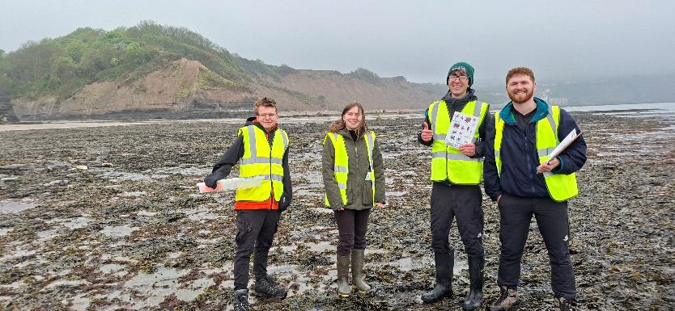

Workshops
Workshops were arranged with those who work in and with the North York Moors National Park. Covering a range of themes, such as wellbeing, mental health and education.

The aim was for workshops to be both educational and fun, with the intention that delegates take something away from the workshops to their own Protected Landscapes, their own lives and their own youth voice groups.

Natural Health Service
Heather McNiff, Head of Engagement and Wellbeing, came to present on the Natural Health Service/Nature Prescriptions project, which is an ongoing collaboration between the North York Moors National Park, Yorkshire Dales National Park, Howardian Hills National Landscape and Nidderdale National Landscape. The project works alongside health service providers to prescribe time in green spaces and nature activities to patients.

Heather illustrated the impacts that these nature prescriptions had on people who took part in the programme, highlighting the importance of time in nature for our mental health, which can result in positive physical health improvements, and ultimately (one of the aims of the project) less stress on the NHS.

Dementia Awareness
On Sunday morning delegates took part in a Dementia Awareness workshop led by Amanda and volunteers from the Alzheimer's Society. Through interactive activities and discussion, participants learned about Alzheimer's disease, the experiences of people living with dementia and how to provide more inclusive support. Some delegates also shared personal experiences of caring for family members affected by dementia.

The workshop highlighted the importance of creating accessible and welcoming Protected Landscapes for everyone. The session provided delegates—many of whom work in engagement roles—with practical knowledge they can apply within their own organisations to better support visitors living with dementia.

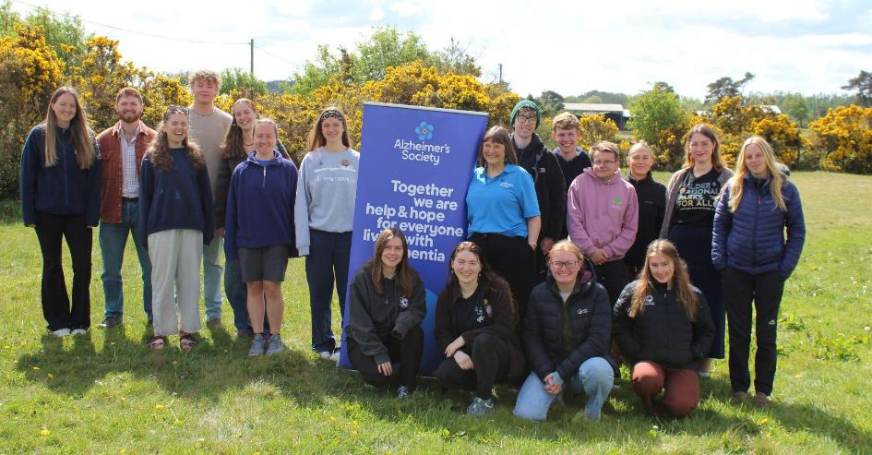

Tom Hind
On Sunday, the North York Moors National Park Authority CEO Tom Hind attended the conference to speak to delegates about role and the invaluable work Youth Voice does. Tom also touched on the roles of Young Co-opted Members.

Tom covered role, and a brief overview of the National Park’s main challenges. Tom discussed his views on the importance of youth involvement in the green sector, and how national collaboration works across the Protected Landscapes of the UK and why this communication and connection is vital.

Delegates were informed on the two Co-option roles, Conversation and Climate Change Co-option (CCC) and the Recreation and Wellbeing Co-option (R&W). Currently, Luke (North York Moors Youth Voice) is the Co-opted Member for the CCC forum and has attended some meetings or sent ahead comments. The forum covers matters including, how the National Park may look over the next century due to climate change. Currently, the role for the R&W C-opted Member is going through the process of recruitment.

Campaign for National Parks
On Sunday delegates took part in the Campaign for National Parks workshop for their new project, National Parks Reimagined. Anna Bedford, Head of Programmes and Operations, and Freya Sareen, Ambassador, explained this workshop was to help build a collective vision of what National Parks should look like.

Delegates were asked to fill out an initial survey about National Parks and watched a video highlighting the issues and concerns faced by people living in National Parks, in particular Bannau Brycheiniog (Brecon Beacons). Followed by a second video featuring a young person and how their National Park has affected them.

Delegates were then asked to step outside and partake in five minutes of sitting quietly to relax and connect with nature and then reflect on how it made everyone feel. Feedback included ‘I nearly fell asleep’ and ‘Peaceful’. Many delegates went straight to the floor as a way to ground themselves.

The main activity involved delegates working in teams or individuals to think about National Parks in the future and how they might look. There were 4 options to choose from.

- Landscape Enhancement
- Thought Cards
- 2035 Zine Making
- What If…? (creative writing).

There were a range of different things made by delegates, with a common theme of creating more accessibility for young people within National Parks.

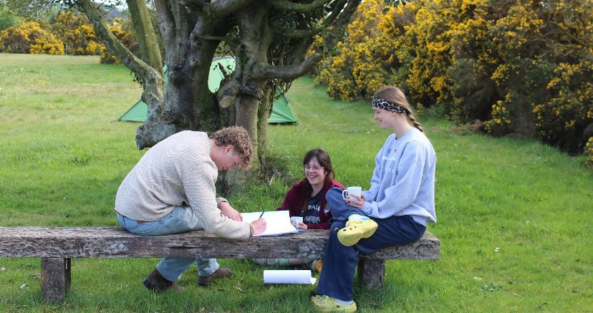

Reconnect Project
Before the delegates left on Monday morning, they had a final workshop with Emma Walker, REConnect Project Officer and Chloe Wainwright, Partnership Manager (Esk and Coastal Streams). Emma and Chloe explained the aim REConnect which is to use the amazing landscape of the North York Moors to deepen local people’s connection to nature while raising awareness of climate impacts and highlighting the importance of river catchments.

Delegates were impressed to hear about the vast number of communities in and around the National Park that the project engages within a wide variety of ways; from events, practical conservation, citizen science and green training (to name a few). Emma and Chloe highlighted the importance of involving local communities in every step of the process, from their logo design to activity ideas, which was useful advice.

Emma and Chloe led a creative activity where delegates choose from a variety of mediums and techniques to create nature art. Having this time to be creative and create a piece of art which summed up all the experiences of the conference was a fantastic way to document all that delegates had seen, learned and achieved over the course of the conference.

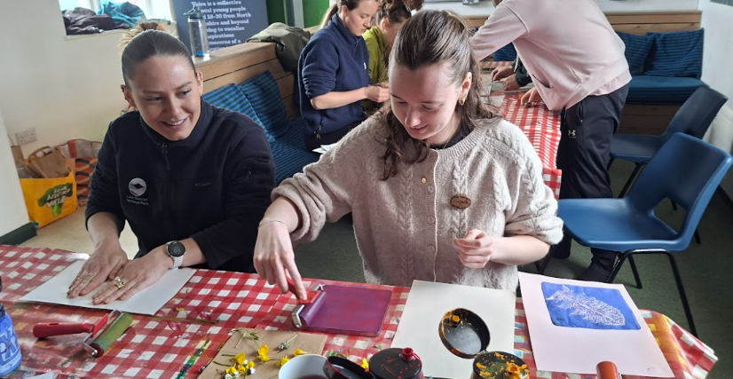

Activities
A range of activities were arranged for the delegates to learn from each other, have fun, work together and enjoy nature to the fullest.

The conference was designed with some relaxed and informal sessions scheduled. Delegates were able to explore and connect to the local environment, as well as have time to connect with each other. Opening up the opportunity to get to know each other in a relaxed social setting. This in turn helped to form bonds which helped connections and passion for working together.

Delegate presentations
Before attending the conference, each Protected Landscape was asked to prepare a short presentation about their work to share with the rest of the delegates. Each presentation included any youth voice work, the wider involvement of young people in the Protected Landscape, and an overview of the landscape itself.

Delegates found it inspiring to hear from other youth voice groups and see the different ways they are creating change in their own Protected Landscapes. Delegates were encouraged to know that there are other groups out there working towards the same cause. While some of the groups are in their infancy, and some have been established for years, this created a fantastic learning opportunity to share wisdom, new ideas and different ways of thinking. The delegates had time to ask each other questions, make notes on lessons learned and continued discussions into the evening and throughout the whole weekend.

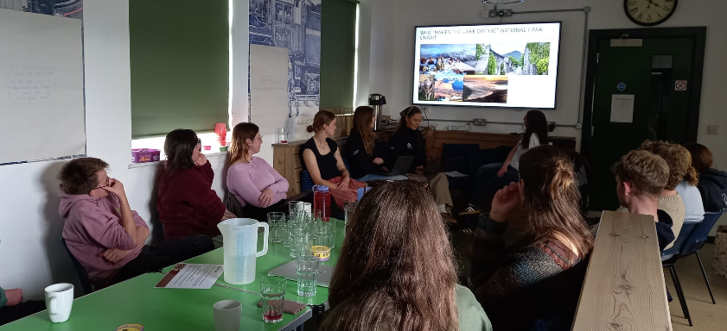

Mindfulness Walk
On Friday evening the delegates were taken on a Mindfulness Walk led by the North York Moors Youth Voice team. The walk started at the conference base, meandering down a public footpath to a nearby woodland. Upon entering the woodland, delegates were blindfolded and formed a chain, holding onto each other's shoulders while descending deeper into the woodland. A new experience for all, the exercise served not only as a bonding experience between delegates, but allowed individuals to use their other senses to navigate the woodland and connect with nature.

While in the woodland the next activity saw delegates take part in 5 minutes of silence and tune into the sights, sounds, textures, smells and tastes (air) that surrounded them. Delegates shared the feelings conjured up during this time and reflected on how nature has played a crucial role in maintaining their wellbeing.
With a new-found calmness, the group walked back to base to resume activities. An activity designed to be still and mindful at the start of the conference greatly appreciated by the delegates as they navigated new relationships.

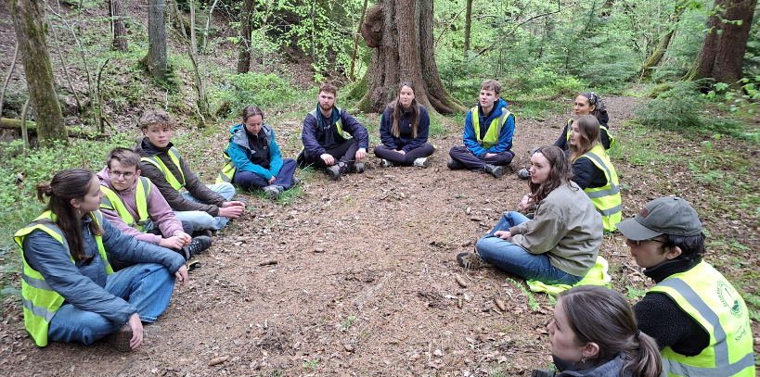

Dawn Chorus
Early in the morning on Sunday a few delegates woke up at the ‘crack of dawn’ to listen to the dawn chorus. Delegates may have been tired and sluggish from the day before. However, Sunday was a much brighter day than Saturday and it was great to get out into the open air first thing.

Delegates used the Merlin Bird ID app and heard species including a cuckoo, curlew, robin and a very loud blackbird! It was a great opportunity to reflect on the first few days and be quiet with a cuppa of our choice. It was great to be with a group of individuals who found it very natural to take a quiet moment and enjoy nature. This is what makes delegates passionate about their Protected Landscapes.

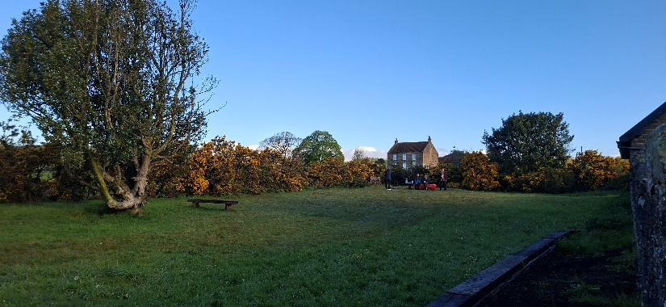

Stargazing
On Sunday evening, delegates gathered for a campfire and celebration—an opportunity to reflect while enjoying the dark skies of the North York Moors National Park International Dark Skies Reserve.

Marshmallows were toasted, and s’mores were made around the fire. Later in the evening, delegates were treated to a stunning view of the night sky, with many stars visible above. This was a good social opportunity, and a chance to feel peace while connecting with nature and the environment at night.

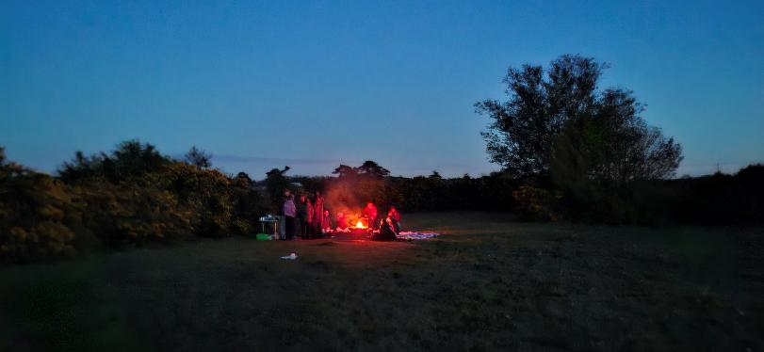

Action planning
NYM Youth Voice organised an ‘action planning’ session to collate some of the ideas of the group. There were four main questions asked to the group. Delegates were encouraged to talk about and share their ideas.

- What does ‘youth voice’ mean to you?
- What would you like to see in your Protected Landscape for youth involvement
- What do you think are the best ways of spreading the word about youth involvement in the nature sector?
- Think of one action you can do to continue the network we have created at this conference.

This was an opportunity to compile and build on ideas from across the conference. There were lots of interesting conversations throughout the conference, both as part of the varied workshops and informally as the group got to know each other and learn about each other's experiences. The Action Planning session was a perfect way to consolidate and share thoughts from these discussions.

There was an amazing diversity in the points made. Some themes, however, also became very clear. Such as; the importance of communication and the benefits that could come from social media. Overall, this was a really productive session that allowed delegates to develop and bring together a lot of ideas that had emerged from the conference and from talking to each other.

“We put in place plans to maintain communication… We would love to do some joint projects together.” - Delegate

In this session young people worked together to create two videos to be shared on the North York Moors National Park Instagram and TikTok accounts. The aim was to promote the work completed by delegates for the benefit of youth voice and collaboration work for systems change.

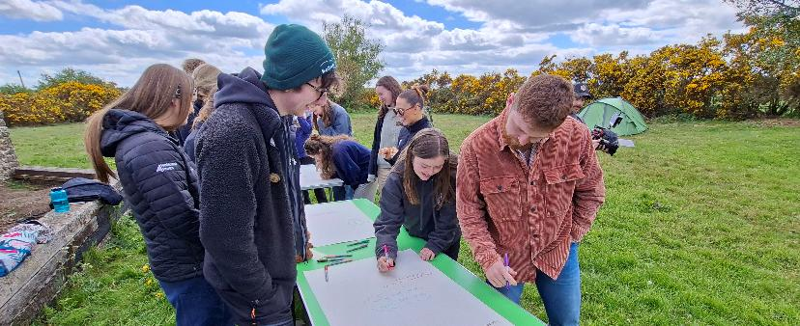

Key Findings
The conference demonstrated a strong demand for a more connected and collaborative approach to Youth Voice across the UK's Protected Landscapes. All 20 delegates (100%) said they would like to attend a similar event again, and 100% (20/20) supported the creation of a national Youth Voice group, highlighting a clear appetite for sustained collaboration beyond individual National Parks.

The most significant outcome was the development of a shared identity and collective purpose. Delegates consistently described the value of learning from one another, sharing good practice and building relationships that would continue after the conference. One participant reflected that they hoped to "learn more about what other Youth Voice groups across the UK were doing so that hopefully we can work more together in the future", while another commented that the conference enabled them to "meet other youth groups and network/connect, look at how we can work together in the future."

Rather than viewing Youth Voice as isolated local initiatives, participants recognised the potential of working collectively to influence change across the Protected Landscapes. Many described leaving with practical plans to strengthen communication, share expertise and collaborate on future projects. One delegate explained that the conference had helped them "put in place plans to maintain communication and hope to have more conferences in the future. We would love to do some joint projects together", while another identified their next step as "setting up [a] communication platform with other Youth Voice groups to share ideas and expertise."

The conference also increased participants' confidence that young people can influence organisational change. Delegates highlighted ambitions to strengthen governance within their own organisations, including becoming co-opted authority members and embedding youth voice within strategic decision-making. Participants recognised that achieving long-term impact would require youth voice to become part of organisational culture rather than relying on individual projects. As one delegate stated, Youth Voice "needs to be core funded, in the management plan", while another emphasised the importance of "listening to young people and taking them seriously. Letting them lead but supporting as much as possible."

Learning from peers was one of the conference's greatest strengths. Delegates repeatedly described feeling inspired by hearing about the work of other Youth Voice groups. One participant commented, "I achieved all of my aims and more... I learned so much over the weekend to take back to my youth board", while another reflected, "It was so inspiring to talk to everyone and I learnt so much."

The findings suggest that the conference delivered more than individual learning. It strengthened a UK-wide network of young leaders, created a shared vision for the future of Youth Voice, and laid the foundations for collective action capable of influencing policy, governance and practice across protected landscapes. Rather than leaving with isolated ideas, delegates left with a stronger sense of belonging to a national movement and a commitment to continue working together to create lasting systems change.

Conclusion
The 2026 Youth Voice Conference demonstrated the value of bringing young people together to shape the future of the UK's Protected Landscapes. Bringing together delegates from nine Protected Landscapes, alongside representatives from the EUROPARC Youth Council, created a unique opportunity to share learning, build relationships and establish a stronger, more connected Youth Voice network across the UK.

The conference achieved far more than knowledge sharing. It created a space where young people felt empowered to influence decision-making, learn from one another and identify practical actions that they could take back to their own organisations. Through workshops, field visits, collaborative discussions and action planning, delegates developed a shared understanding of the opportunities and challenges facing Protected Landscapes and recognised the value of working collectively to address them.

Evaluation findings demonstrate the strength of this collective ambition. All delegates (100%, 20/20) said they would attend another Youth Voice conference and supported the creation of a UK-wide Youth Voice group. Participants described the conference as an opportunity to "meet other youth groups and network/connect, look at how we can work together in the future" and expressed ambitions to continue communication, develop joint projects and strengthen youth representation within their own organisations.

Perhaps the most significant legacy of the conference is the creation of a shared vision. Young people no longer see Youth Voice as a series of individual projects within separate Protected Landscapes, but as a connected movement capable of influencing policy, governance and practice across the UK. The conference has laid the foundations for sustained collaboration, demonstrating that when young people are trusted as partners and connected through a national network, they can drive meaningful change that extends well beyond a single event.

The conference marks the beginning of an ongoing programme of collaboration rather than a standalone event. Delegates have committed to maintaining communication through a shared network, sharing ideas and good practice, developing collaborative projects and championing Youth Voice within their own organisations. Alongside this, conference leaders will seek funding and strategic partnerships to support the continued growth of a UK-wide Youth Voice network and create opportunities for young people to influence the future of Protected Landscapes together.

Appendix

- Youth Voice Conference 2026 evaluation
- Newsletter
  - New Forest Youth Board Newsletter
- Blogs
  - Youth Voice Conference 2026 - Action Renewables
  - Insights – LDNP
  - Reflections - NFNP
- Social media
  - Instagram
  - LinkedIn

