SoilsPark Project Report

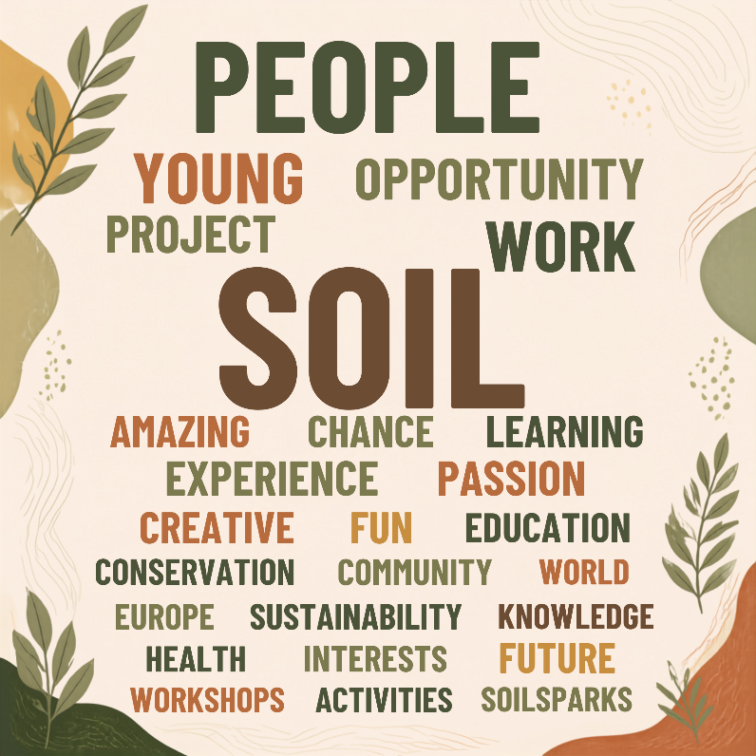
In July of this year, young people from across Europe came together fort the first stage of the SoilsPark Project. This initiative united a highly diverse group of individuals with a shared advocacy for nature, all coming from various youth groups dedicated to environmental protection. In total, 30 young people gathered from 23 different countries.
Meeting in Reims, France, marked the start of deep collaboration, friendship, and a shared purpose. The strength of this project lay in its interdisciplinary approach, bringing together young people from vastly different backgrounds across both the natural and social sciences to work within protected areas.
Figure 1: Word Cloud of EUROPARC AIs members participation.

Laura Rosa – EUROPARC Youth Council member
As an educator, member of the Youth Council and someone who works directly within protected areas in Ireland, participating in this project was incredibly rewarding. It was inspiring to see a form of community where everyone supported one another for the same vital purpose: nature and soil protection.
The project reminded me how to spark the same connection and passion for conservation in others. I am leaving this experience with innovative ideas that I am eager to implement directly into my ongoing work with the National Parks & Wildlife Service (NPWS) in Ireland.
By gathering and sharing ideas, we were able to capture diverse perspectives and innovative ways to engage youth in soil protection. This collective effort directly enriched the content of the SoilSparks Campaign to address EU Mission Soil objectives, while simultaneously building practical educational toolkits and programmes specifically designed for rangers and educators.
To learn more about this first stage of the campaign, please click the link below:
https://www.europarc.org/news/2026/09/soilsparks-with-youth-plus/

Community Voices: Atlantic Isles Section
Several members from youth groups within the EUROPARC Atlantic Section were able to join this opportunity. As shown in the word cloud above, which captures feedback from the participants, this was an opportunity we are deeply proud to have been a part of.

Katie’s Quote - Yorkshire Dales
“Being part of the SoilSparks Project was a fantastic opportunity to connect with other young people involved in National Parks throughout Europe. I really enjoyed the workshops, where we explored creative ways to educate young people about soil, as well as getting the chance to explore Reims”

Cordelia’s Quote – Loch Lomond and the Trossachs National Parks
“I loved having the chance to meet likeminded young people who are passionate about conservation and the outdoors in general. The opportunity to gain hands-on experience working with soil was amazing for me as a geography student, and the chance to influence young people around Europe is incredibly exciting to me. I can’t wait to see what becomes of the SoilSparks Project and I’m incredibly happy to be able to have part of it”

Ryan’s Quote – Landscape NI
“SoilsParks was an amazing opportunity for me to get dug in and learn what soil is all about in a fun a creative environment. It was great meeting so many passionate people from all around the world coming together to work on something so important, and I can’t wait to see where we go next!”

Josie’s Quote – New Forest
“The online learning was perfect for building my knowledge of soils before the co-creation camp; it provided an expansive overview, and a fuller picture of what soil health is like today within multiple contexts.
The co-creation days offered me so many amazing opportunities to put my skills into practise, working through multiple forms of engagement in order to nurture people’s interests in soils, getting them to care and become more curious to find out more”

Ambrose McCartney – Isles of Man Biosphere Youth Network
“As someone who’s passionate about sustainability but knew little about soil before SoilsParks, I found the project to be both fun and very educational. There was a good balance of work and educational activities, and the work was structured in a way that encouraged everyone to contribute. I was also touched by how far some people travelled to get there. It was a great reminder of the passion our generation has for building a sustainable future.
Overall, the weekend was an amazing experience for learning and making new, like-minded friends. I very much look forward to being a SoilsParks ambassador and continue where I can”

Iona – The Cairngorms
“I really enjoyed the experience. It was my first time working on a soil related project and I found the workshops really good for teaching me all about soil’s role, why it’s important and the challenges with protecting it. The in-person event in Reims was good, and I definitely think it was necessary for it to be in-person as that made discussion much easier”

Acknowledgements
A big thank you to the EUROPARC Youth Office Jessica Micklem – Kolenic for her work and coordination among us; Michele Herrmann for her expertise and the Bantani Education team, Maria Kazarez and Elin McCallum for their teaching, enthusiasm and understanding with the entire youth group!
Thank you to the Montagne de Reims Regional Natural Park staff for their guidance and engaging activities during the co-creation camp.
Also, thanks to Ryan for the support with this article!

